Driving Directions to the Odessa Baptist Church
111 Fowler Place
Odessa, New York 14869

Our church can be reached from Route 224—an East-West route through the Village of Odessa.
From the East: As you approach Odessa from the East, look for signs for Route 228. At the intersection where Route 228 heads north toward Mecklenburg, please turn to the left onto Fowler Place. You will curve around to the left and up a small hill, passing a yellow house at the top of the hill. The church will be on your left, just after a yellow house.
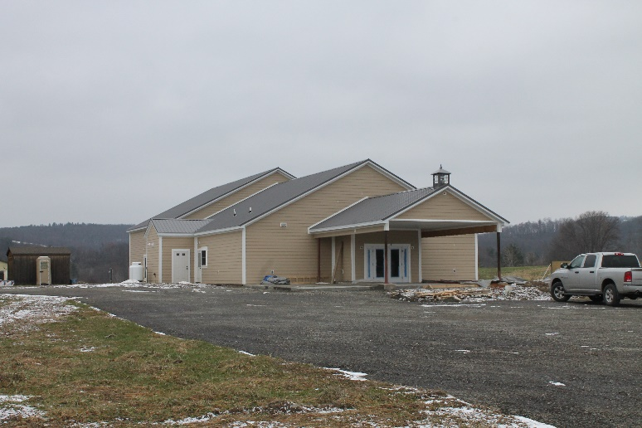
From the West: You will turn onto Route 224 from Route 14 or some other route. You will drive through the business district of Odessa. Coming from the East, you will see a Dandy Mart and the Fire Station on your right. You will pass the Post Office on your left, drive under an old railroad viaduct, and see the School Bus Garage on your left. Just after the bus garage, you will see a sign for Route 228 to the north. At that same intersection, turn right onto Fowler Place. You will curve around to the left and drive up a small hill. You will pass a yellow house; the church will be on your left.
From the North (on Route 228): You will be driving south, toward Route 224. At Route 224, stop and then continue through the intersection onto Fowler Place. You will curve around to the left and see a yellow house at the top of the hill. The church is on your left.

